**BILAN TUTORAT**

**Année 2024**

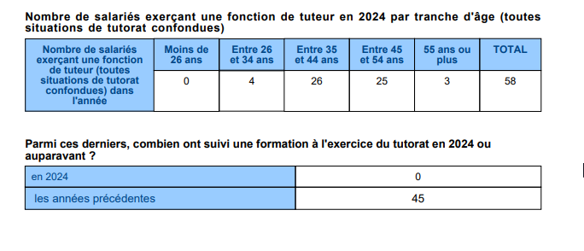



Dépenses 2024 :

|  |  |  |  |  |  |  |  |
| --- | --- | --- | --- | --- | --- | --- | --- |
|  | GA0 | GA71 | ES11 | ES12 | ES929 | ET41 | TOTAL |
| TOTAL | 16 139,52 € | 1 012,05 € | 319,59 € | - € | - € | - € | 17 471,16 € |